
 | 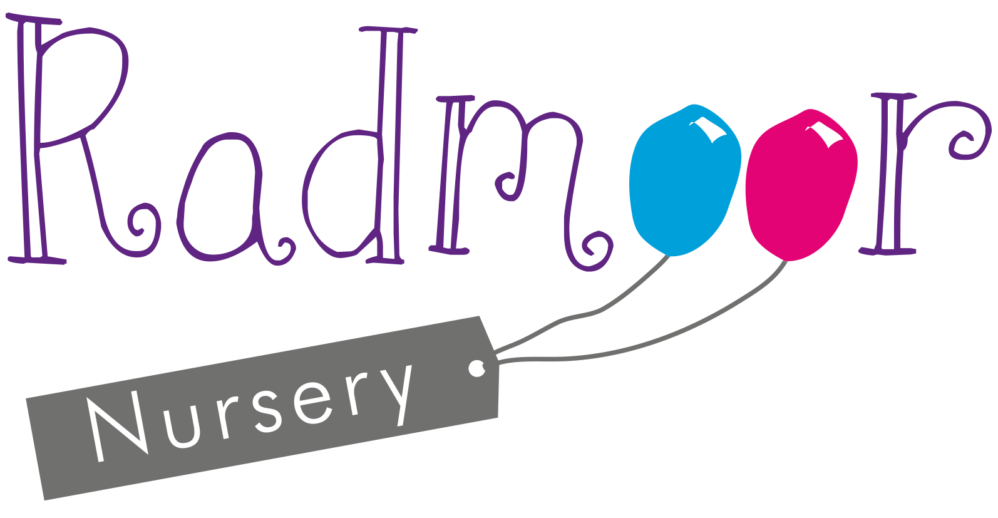 |  | 
CONFIDENTIAL
PLEASE COMPLETE ALL DETAILS IN BLOCK CAPITALS
Child’s Details  Surname ________________________ Forenames ____________________  Address ______________________________________________________  _______________________________ Postcode _____________________  Which Parent or Carer does the child normally live with _________________  Date of Birth _____________________ Gender Male Female  Nationality ______________________ Religion ______________________  Language spoken at home _______________________________________  Ethnicity (Please tick)  White British Mixed White & Black Caribbean Asian or Asian British  Irish White & Black African Indian  Traveller of Irish Heritage White & Asian Pakistani  Gypsy/Roma Any other mixed background Bangladeshi  Any other White background Chinese Caribbean  Any other Asian background Black or Black British African  Any other Black background  Please return this form when complete to:  Radmoor Day Nursery  Radmoor Road  Loughborough  Leicester  LE11 3BT |  |  |  | Registration Form: Radmoor Holiday Club
Child’s Details
Special Educational Needs

Does your child have any Special Educational Needs Yes No

If yes, does your child have a Statement of Educational Yes No
Needs maintained by the LEA

Does your child have any Special educational Needs Yes No
but no statement

Medical Details

Does your child have any medical conditions Yes No

Details _____________________________________________________________

Does your child take regular medication Yes No

Details _____________________________________________________________

Does your child have any allergies Yes No

Details _____________________________________________________________

Are there any medical procedures that are
prohibited by family religion or beliefs Yes No

If yes, please state ___________________________________________________

Dietary Requirements

Can your child eat anything? Yes No

Is your child vegetarian? Yes No

Does your child have a food allergy or intolerance? Yes No

Details ______________________________________________________________

Healthcare Details

Doctors Name _______________________________ Telephone_________________

Address__________________________________________postcode_____________

Child’s Details
Father/Carer Details
Surname_________________________________Forename__________________
Home Address (If different from Child’s) ________________________________________
__________________________________ Postcode ________________________
Home Telephone Number ______________________________
Mobile Telephone Number _____________________________
Company Name______________________________________________________
Company Address ____________________________________________________
__________________________________ Postcode ________________________
Email _____________________________ Work Telephone ___________________

Mother/Carer Details
Surname ______________________ Forename _________________Mrs/Ms/Miss
Home Address (If different from Child’s) ________________________________________
__________________________________ Postcode ________________________
Home Telephone Number _____________________________
Mobile Telephone Number_____________________________
Company Name______________________________________________________
Company Address ____________________________________________________
__________________________________ Postcode ________________________
Email _____________________________ Telephone _______________________

Parent/Carer Details
Emergency Contacts

Please supply names and address of contacts, who could attend at short notice, in an emergency if we are unable to contact you or child’s Parent/Carer.

1st Contact

Name _____________________________ Relationship to Child ______________

Address ____________________________________________________________

Telephone __________________________ Mobile __________________________

Can this person collect your child in an Emergency situation? Yes No

2nd Contact

Name _____________________________ Relationship to Child ______________

Address ____________________________________________________________

Telephone __________________________ Mobile __________________________

Can this person collect your child in an Emergency situation? Yes No

Persons Authorised to Collect

Please give names of persons authorised to collect your child INCLUDING
Parent/Carers. Please supply a photograph of all persons authorised to collect.

- ________________________________ Relationship to child _______________

- ________________________________ Relationship to child _______________

- ________________________________ Relationship to child _______________

- _______________________________ Relationship to child _______________

To ensure your child’s safety and to avoid delays when collecting, please agree a password
to be used on arrival by any of the individuals named above or to be provided in an emergency

The agreed password is __________________________________

Emergency Contacts
Consents

Offsite Activities Yes No
I agree that Staff can take my child on walks in the local community for Off Site Activities. Staff will inform me, in writing, and request specific consent for activities that involve the use of Public and or any other forms of transport

Photographs within childcare setting Yes No
I agree to photographs of my child to be used on displays, to support activities and provide evidence for Ofsted. These photographs can also be used for the children to refer to

Photographs for Promotional Literature Yes No
I agree to the use of photographs of my child to put on promotional literature, displays for Open Evenings and for supporting student/work experience placement portfolios

Photographs for use on the Nursery Website Yes No
I agree to the use of photographs of my child appearing on the Nursery website

Face Painting Yes No
I agree for my child’s face to be painted

Hypoallergenic Plasters Yes No
I agree for hypoallergenic plasters to be administered to my child

Pain and Fever Relief Yes No
I agree that my child can be given Calpol for pain and Fever Relief

Allergic Reaction Relief Yes No
I agree to Piriton Syrup being administered to my child in the event of an allergic reaction.

Sun Cream Yes No
I agree that sun cream can be applied to my child

Emergencies Yes No
I agree that in the event of an emergency staff can seek emergency medical advice or treatment

Hair Braiding Yes No
I agree that my child can be involved in this activity if they have asked for it to be done

DVD Viewing
I consent to my child watching a Certificate ‘U’ film Yes No

I consent to my child watching a Certificate ‘PG’ film Yes No
Consents
With changes in recent legislation we now need authorisation from parents as to who has legal parental responsibility and whom you authorise to take on legal parental responsibility in the event of your absence.

This relates to authorisation of medication, outings, activities undertaken and any other documentation produced that requires a signature e.g. acknowledgment of accidents, administration of medication etc.

Legal Parental Responsibility:

Name (please print)_______________________ Signature ______________________

Name (please print)_______________________ Signature ______________________

Name (please print)_______________________ Signature ______________________

Persons Authorised to take on Legal Parental Responsibility in the absence of the parent:

Name (please print)_______________________ Signature ______________________

Name (please print)_______________________ Signature ______________________

Name (please print)_______________________ Signature ______________________

Name (please print)_______________________ Signature ______________________

The information you provide on this form will be shared within Loughborough College for administrative and health and safety purposes and with other organisations will include inspection and government or other regulatory bodies. The college will not divulge any information on this registration to any unauthorised agency without your prior written consent. At no time will any personal information about you or your child be passed on to organisations for marketing purposes. Because of the Data Protection Act 1988 we need you to sign the following “consent to process” clause. If you require any further information about this please contact the MIS Manager at the college.

I agree to Loughborough College processing my child’s personal data or any other data the college may obtain from me or other people. I agree to the processing of such data as detailed above for any purposes connected with my child whilst on college premises, or for any legitimate reason. I have read the statement above relating to the Data Protection Act 1998 and agree.

Signed by the Person with Legal Parental Responsibility
Parent/Legal Guardian

Signed ___________________________ Date __________________________

Please Print ______________________

Notes (please supply us with any additional information you feel we should know about your child)

Notes


 | 
Radmoor Day Nursery  Radmoor Road Tel: 01509 515456  Loughborough Ofsted No. 223262  Leicestershire E:nursery.enquiries@loucoll.ac.uk  LE11 3BT  Holywell  Out of School Club Tel: 07881 811 347  Berkeley Road Ofsted No. EY 318306  Loughborough Administration: 01509 515456  Leicestershire E:nursery.enquiries@loucoll.ac.uk  LE11 3SJ  Camp Energy  Out of School Club Tel: 07771 504 973  Greenfields Sports & Social Club Ofsted No. 226262  Holt Drive Administration: 01509 515456  Loughborough E:nursery.enquiries@loucoll.ac.uk  Leicestershire  LE11 3HZ |  |  |  | www.radmoornursery.co.uk



