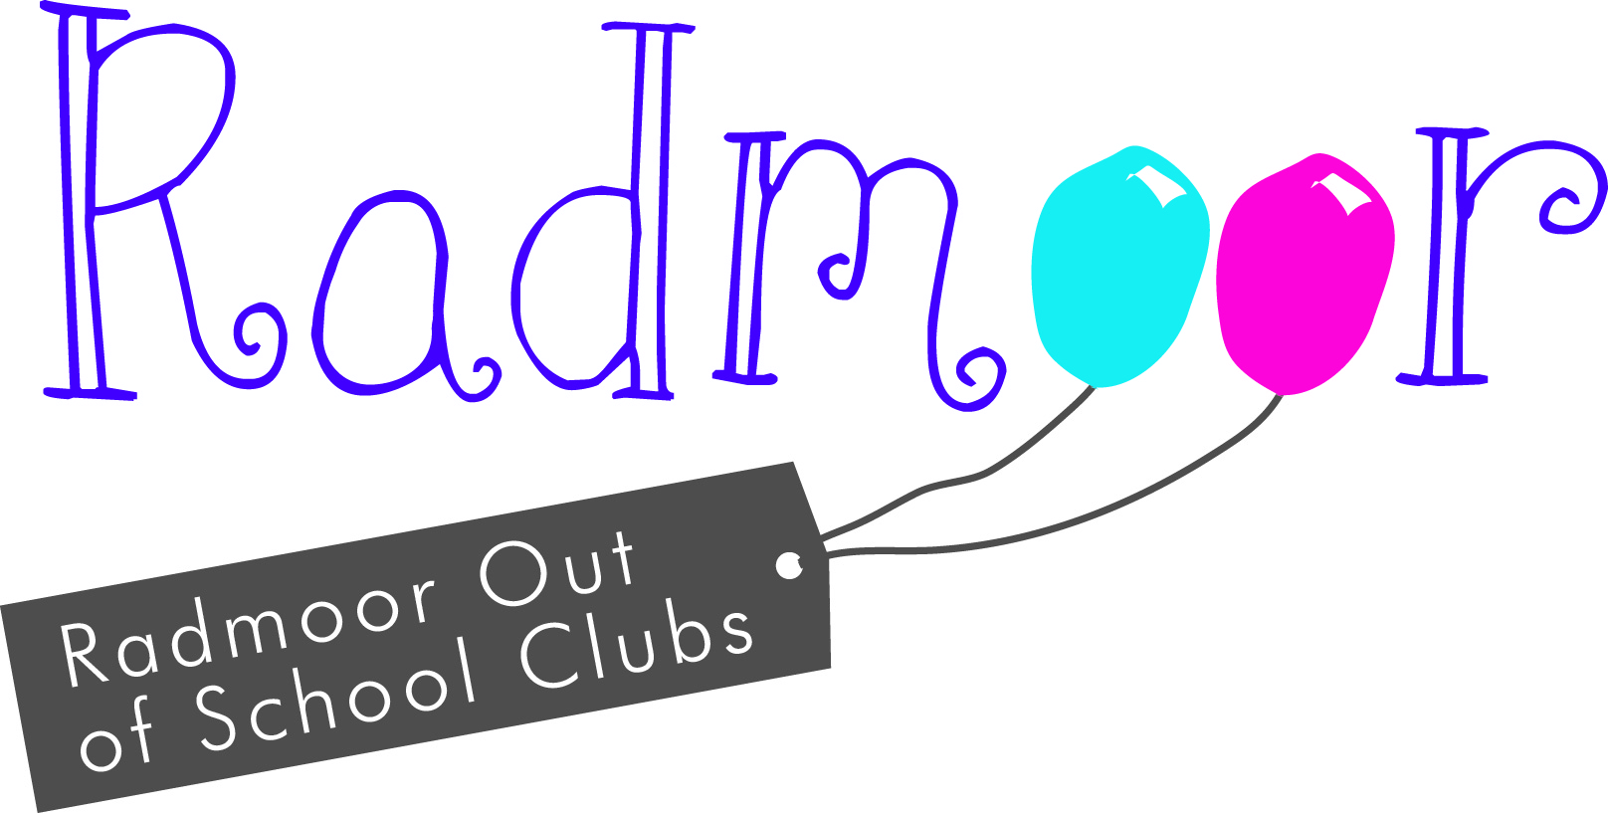

Radmoor Holiday Club
Booking Form Summer 2018 - Venue: Radmoor Nursery (Large room in the Fairbairn Building)
(Situated on the left as you enter the College Campus via Radmoor Road just before the RNIB College)
Date of Birth

Please complete the booking form, selecting the type of session you require e.g. FD, SD, AM or PM

FD = 8:00am - 6:00pm SD = 8:30am - 3:30pm
AM = 8:00am - 1:00pm PM = 1:00pm - 6:00pm
 | Mon | Tues | Weds | Thurs | Fri
WEEK 1 Session required FD/SD/AM/PM | 16th July | 17th July | 18th July | 19th July | 20th July
WEEK 2 Session required FD/SD/AM/PM | 23rd July | 24th July | 25th July | 26th July | 27th July
WEEK 3 Session required FD/SD/AM/PM | 30th July | 31st July | 1st August | 2nd August | 3rd August
WEEK 4 Session required FD/SD/AM/PM | 6th August | 7th August | 8th August | 9th August | 10th August
WEEK 5 Session required FD/SD/AM/PM | 13th August | 14th August | 15th August | 16th August | 17th August
WEEK 6 Session required FD/SD/AM/PM | 20th August | 21st August | 22nd August | 23rd August | 24th August

General Reminder – Please provide your child with a packed lunch, a couple of snacks and a refillable drinks bottle. All foods brought to the club must be NUT FREE.
Details of the activities planned will be available nearer the time.
**Please be aware that there has been a slight increase in the Fees**

Holiday Club Rates

Daily Rate University Employee Rate Staff Rate
Full Days 8:00 - 6:00 | £28.00 | £23.00 | £25.00
Short Days 8:30 - 3:30 | £25.00 | £20.00 | £20.50
AM 8:00 - 1:00 | £18.00 | £15.00 | £14.50
PM 1.00 - 6.00 | £18.00 | £15.00 | £14.50

There is a 10% discount for the second/third child when siblings attend the club on the same day.
Once we have received your booking form and we have confirmed availability, your payment will become due as per the schedule below.
- July sessions booked – Payment due at the time of booking.
- August sessions booked – Payment due by 6th July.
Any other bookings after the 6th July must be paid for at the time of booking.

Non-payment will result in your booking being withdrawn. You will still be charged for the sessions booked, regardless of any cancellations or place being withdrawn.
I have previously completed a Holiday Club Registration Form and confirm that my details have not changed.
If the details have changed please inform us via email to nursery.enquiries@loucoll.ac.uk

I have read the information booklet

Payment methods
Payment can be made by the following:-
Cheque: Payable to Loughborough College and sent to the address at the bottom of the page.
Cash: Accepted at the nursery office.
Telephone payment: All credit and debit cards except American Express. Please contact the office between the hours of 9.00am-2.30pm.
Internet banking: Details are as follows, Sort code: 16-24-23 Account number: 10081373. Reference: Childs name
Salary sacrifice vouchers: Please telephone the nursery office for details on 01509 515456
I shall be making payments by

Loughborough University Employees only:
I am eligible to claim the Loughborough University subsidy

If yes:
Name of Employee (please print)

Department

Form completed by (Name of the person with Legal Parental Responsibility)

Parent/ Guardian

Any Other Details
Booking May
Please return all electronically completed forms to holiday.clubs@loucoll.ac.uk or paper based to: Radmoor Day Nursery, Radmoor Rd, Loughborough, Leicestershire, LE11 3BT.
Enquiries 01509 515456

During Holiday Club hours (8.00am - 6.00pm) please contact us on the Club mobile number:
07771-504973.

