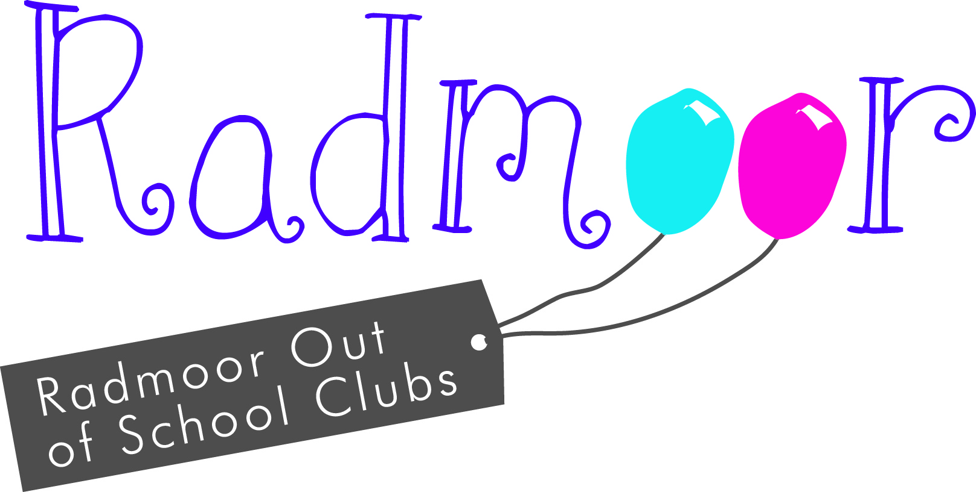
Radmoor Holiday Club
Booking Form Summer 2017 - Venue: Fairbairn Bulding
(Situated on the left as you enter the College Campus via Radmoor Road just before the RNIB College)

Child’s Name

Date of Birth

Please complete the booking form, selecting the type of session you require e.g. FD, SD, AM or PM

FD = 8:00am - 6:00pm SD = 8:30am - 3:30pm
AM = 8:00am - 1:00pm PM = 1:00pm - 6:00pm
Please provide your child with a packed lunch, a couple of snacks and a refillable drinks bottle. All foods brought to the club must be NUT FREE.
 | Mon | Tues | Weds | Thurs | Fri
WEEK 1 Session required FD/SD/AM/PM | 17th July | 18th July | 19th July | 20th July | 21st July
WEEK 2 Session required FD/SD/AM/PM | 24th July | 25th July | 26th July | 27th July | 28th July
WEEK 3 Session required FD/SD/AM/PM | 31st July | 1st August | 2nd August | 3rd August | 4th August
WEEK 4 Session required FD/SD/AM/PM | 7th August | 8th August | 9th August | 10th August | 11th August
WEEK 5 Session required FD/SD/AM/PM | 14th August | 15th August | 16th August | 17th August | 18th August
WEEK 6 Session required FD/SD/AM/PM | 21st August | 22nd August | 23rd August | 24th August | 25th August
Details of the activities planned will be available nearer the time.

Holiday Club Rates

Full Days 8:00 - 6:00 | £27.00 | £22.00
Short Days 8:30 - 3:30 | £24.00 | £19.00
AM 8:00 - 1:00 | £17.50 | £14.50
PM 1.00 - 6.00 | £17.50 | £14.50
Daily Rate University Employee Rate

All bookings must be paid for regardless of attendance.

There is a 10% discount for the second/third child when siblings attend the club on the same day.
Once we have received your booking form and we have confirmed availability, your payment will become due as per the schedule below.
- July sessions booked – Payment due at the time of booking.
- August sessions booked – Payment due by 5th July.
Any other bookings after the 5th July must be paid for at the time of booking.
Non-payment will result in your booking being withdrawn.
I have previously completed a Holiday Club Registration Form and confirm that my details have not changed.
If the details have changed please inform us via email to nursery.enquiries@loucoll.ac.uk

I have read the information booklet

Payment methods
Payment can be made by the following:-
Cheque: Payable to Loughborough College and sent to the address at the bottom of the page.
Cash: Accepted at the nursery office.
Telephone payment: All credit and debit cards except American Express. Please contact the office between the hours of 9.00am-2.30pm.
Internet banking: Details are as follows, Sort code: 16-24-23 Account number: 10081373. Reference: Childs name
Salary sacrifice vouchers: Please telephone the nursery office for details on 01509 515456
I shall be making payments by

Loughborough University Employees only:
I am eligible to claim the Loughborough University subsidy

If yes:
Name of Employee (please print)

Department

Form completed by (Name of the person with Legal Parental Responsibility)

Parent/ Guardian

Any Other Details
Booking May
Please return all electronically completed forms to holiday.clubs@loucoll.ac.uk or paper based to: Radmoor Day Nursery, Radmoor Rd, Loughborough, Leicestershire, LE11 3BT.
Enquiries 01509 515456

During Holiday Club hours (8.00am - 6.00pm) please contact us on the Club mobile number:
07771-504973.

